Making and Difference With Data (MADD), and Data for Neighbourhoods and Regeneration (data4nr) – future opportunities and priorities

Local Public Data Panel on 29th September

Paper, for discussion from: Steve Peters

Introduction

- This paper seeks the Panel’s views on DCLG’s proposals to take forward the MADD and Data4nr initiatives over the next 12 months.

- The main aspects of the proposal are that DCLG will:
- Contribute £6k, for routine maintenance and support of the MADD site.
- Fund data4nr (£10k), to continue providing its register of government datasets at district and sub-district level – funding is for 12 months support
- Provide an additional £20k, to be targeted at rebranding and enhancing data4nr as a “data4local” service, and strengthening linkages with MADD.

- This funding package has been endorsed by DCLG’s Executive Team as part of the Department’s ‘quick wins’ programme to improve data publication.

Background

Data4nr – current service

- Commissioned by CLG in 2005 to support practitioners in a local partnership context, data4nr is a trusted, reliable service for signposting datasets available at district (local authority) and sub-district levels. Annex A provides further background on the scope and nature of the current data4nr service.

- Currently, data4nr has 800 registered users drawn from policy and performance decision makers and analysts in more than 300 organisations: local and central government bodies, service providers (3rd sector and commercial), academic and commercial research organisations, and think-tanks. The website averages 3,500 visits per month.

- We know that data4nr’s users value its rich data content and functionality. Positive feedback from user consultation and surveys has included:

“I do area profiles to inform policy development. Data4nr.net has transformed the ease and effectiveness of what I do” Local Authority policy officer in Chief Executive’s department

“This immediately narrows down what I'm looking for, along with the filters of geographical level. Excellent”. Local Authority Researcher

“'Thank you for a very useful contribution to the safer and stronger communities work of ourselves and our partners”. Safer and stronger communities partnership manager.

Data4nr future opportunities and development priorities

- There is obvious value in improving data4nr, so that:

- It is seen and used more widely (beyond the neighbourhoods and regeneration domains) as a mechanism for discovering and understanding datasets available at district and sub-district level.
- Its content and functionality can be integrated directly into other third-party sites and services.

- The proposal is for DCLG to provide circa £20k to fund:
  - Rebranding as a “data4local” service, to include a visual refresh with DCLG’s logo taking more of backstage (as per Making a Difference With-Data).
  - Improvements to searching and navigation functionality.
  - Development of a “use anywhere” data4local widget. This builds on data4nr’s current API, which is currently used in three external services. The widget would be similar to standard twitter widgets, for example, and enable data4nr content/ functionality to be easily incorporated on any third party site. I envisage that it would show datasets matching particular filters and search criteria (e.g. economic data available at LA level or below and/or with trend data) [Annex B illustrates how it might work, look and feel].

Alignment with MADD

- DCLG recognises the MADD website’s significant role and contribution as a focal point for data users to come together around topics of shared interest. As such, DCLG is happy to contribute £6k towards maintaining and supporting the site in the short to medium term.

- Alongside this, I would like to explore opportunities for joining up MADD and data4nr: for example, to integrate the new data4nr widget in the MADD site, thereby providing MADD contributors with more detailed intelligence on data availability at district and sub-district levels.

- Work to scope improvements to data4nr has also identified opportunities to go further. For example, data4nr’s providers (OCSI) tell us how feedback from local communities, voluntary groups, local government and partners often highlights “data is not enough – we need help in what to do with it”.

- Data4nr, in partnership with MADD, could support this need by providing illustrations and links to help users cross the all-important gap between accessing data and using data effectively.

- One start point here could be to refresh the library of data toolkits and resources (www.data4nr.net/analytical-tools/). This was developed for the 2008 update of Data4nr, but currently not updated (and some of the original resources have since disappeared due to closure of relevant sites and services).

- This could be a significant resource in its own right to support local (and national) users wanting to use data effectively, e.g.:
- Organise the resources around a framework of “understanding and using data”, with resources tagged and searchable by theme/ tag
- Update the list of resources
- Add description of external resources (including how to use)
- Add examples of how-to-use datasets, with the narrative linked to needs for local information. Also link to (or generate) examples that use important new and/or revised published datasets. For example, when the IMD 2010 was published, many groups carried out analysis for local areas which provide useful pointers to the analysis that can be carried out. This could be facilitated with a “This dataset has been used here” button on any dataset, allowing users to add links to publications and weblinks.
- Add examples of data visualisations – including links to the DataViz project (www.improving-visualisation.org) and other visualisation examples and resources

Steve Peters
September 2011
Annex A

Data4nr – Current service

Maintaining content content in the catalog
- Fortnightly updates to:
  - Detailed list of key local and neighbourhood data sources
  - Direct links to each source, including web-links, where available
  - Information on geographic levels that each source is available for.
  - Info on updating frequency for each dataset, and time series
  - Summarising the data currently available from sources such as the Neighbourhood Statistics website, other official statistics etc.
- Identifying sources that can be broken down by social characteristics and categories useful in monitoring equalities strand such as gender, age, ethnicity, religion/belief and disability
- Scanning for and incorporating new and undiscovered data sources.
- Updating broken links (eg, ONS have recently relaunched their entire site, breaking every existing link)

Supporting and maintaining the data4nr service

- Fortnightly mail-out to 700+ subscribers
- Including forthcoming sources of relevant data, (consulting with ONS, CLG and other data providers).
- Providing links to local information systems (Data4nr holds the definitive list of local authority data systems)
- Providing links to appropriate analytical tools developed by CLG, ONS, IDeA and others

New functionality to be added
- Add JSON to the list of supported metadata formats (currently includes html, csv, xls, and rss format.)
- Incorporate links to data publishers RSS feeds for future releases (where available)
Annex B – data4nr “widget” concept

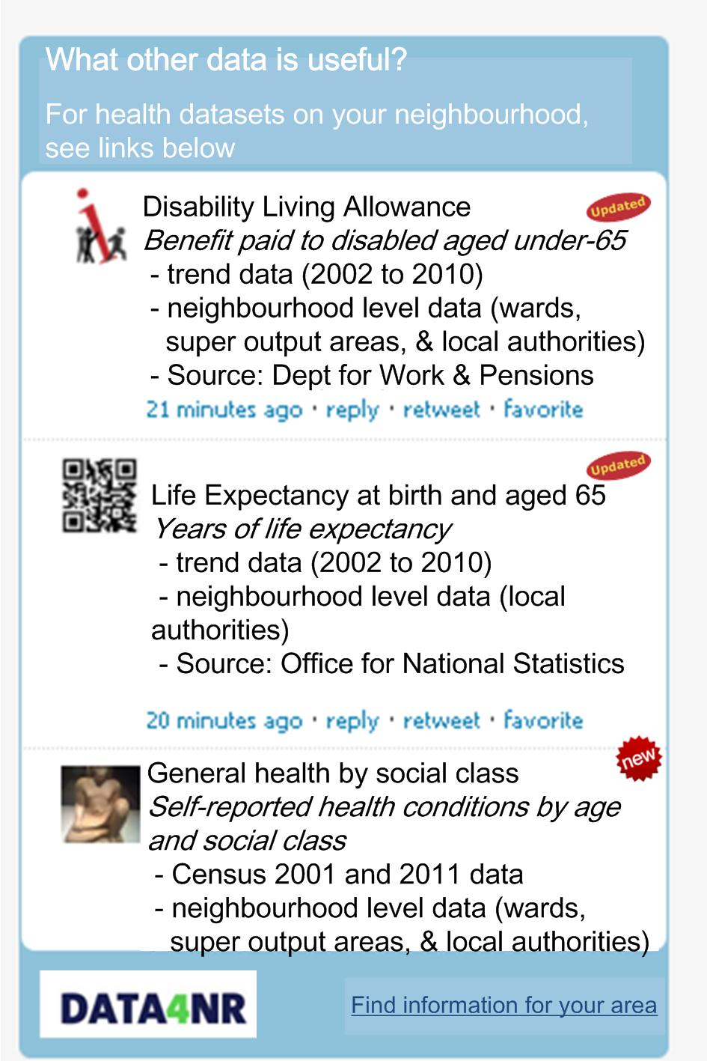
Datasets signposted from Data4nr, matching search terms
Icons identify new and updated datasets
Links through to Data4nr to find more detailed data
Data4nr widget to embed into any site for any user (eg as per Twitter widget)
Customisable title, search term and filter – drawing data in real time from Data4nr

Data4nr’s API is used by public and academic data observatories to identify published datasets by subject. Eg www.nerip.com/data4nr, www.adls.ac.uk/data-providers/ons/inter-departmental-business-register/, www.oxfordshireobservatory.info

